Central Wisconsin Health Partnership
Comprehensive Community Services (CCS)
Regional Coordinating Committee (RCC) Meeting
Wednesday, September 20, 10:00 – 12:00

Participants: Erin Kobylski, Kelly Oleson, and Diane Fletcher – Adams County; Kate Meyer, Jason Jerome, and Greg Metzler – Green Lake County; Ashlee Schanke – Juneau County; Jeremy Lee, Wendy Toutant, Rachel Nelson, and Mary Walters (Chair) – Marquette County; Clara Voightlander (Co-Chair), and Terri Billington – Waushara County; Shelli Essmann (Southeast Regional Office); Lori Martin, CCS Regional Coordination

- Introductions

- Approval of agenda
- Jason Jerome made a motion to approve the agenda, motion seconded by Jeremy Lee, all in favor, motion carried.

- Approval of meeting minutes from June 14, 2023, meeting
- Kelly Oleson made a motion to approve the June 14, 2023 minutes, motion seconded by Jason Jerome, all in favor, motion carried.

- CCS Education Presentation – CWHP Regional Shared Services
Lori Martin, CCS Regional Coordinator
- See Appendix A for PowerPoint slides

- Sharing of Success in CCS – Engaging individuals with substance use needs
Terri Billington, Waushara County
- See Appendix B for PowerPoint slides
- Discussion – request for Terri to present to our 6-county service facilitators. Lori will help coordinate.

- County Roundtable
- Adams County – Continuing to look for PLEx member for this Committee. Experiencing a lot of success with their crafts and creative coping group which includes individuals involved in both CCS and the Community Support Program (CSP) and meets every 6 – 8 weeks.
- Green Lake County – Taking a look at what’s working well and what’s not related to the program. Their CCS Coordinating Committee reviewed the CCS paperwork and eliminated duplication and unnecessary documents. The assessment document was modified to be more narrative, less checkboxes. Working to make the role of the Mental Health Professional (MHP) and Substance Use Professional (SUP) more consistent. They have identified 5 individuals who can fulfill these roles and are looking forward to the MHP/SUP training being held in November.
- Juneau County – Three CCS consumers recently presented to the County Board about how CCS has affected them. They have three new service facilitators, one dual Coordinated Services Teams (CST) and CCS; there is one open service facilitator position.
- Marquette County – Alli, who was a service facilitator, has transitioned into a therapist role. Wendy was recently hired as a new service facilitator. Recently added two new service provider agencies. At the last local CCS Coordinating Committee meeting, CST Coordinating Committee members joined the meeting. The decision was made to combine the two committees with the first joint meeting in October.
- Waupaca – not represented; Chair requested Lori reach out.
- Waushara – Have seven new individuals with substance use disorder in CCS. Also have a Certified Peer Specialist now working full-time on staff. Their CST Coordinating Committee will also be combining with their CCS Coordinating Committee.

- Regional Training and Quality Assurance Report – Lori Martin, CCS Regional Coordinator
- Training update given during educational presentation.
- Quality Assurance
- At the last meeting Lori shared she has been participating in a monthly CCS Quality Improvement (QI) Community of Practice group, which offers an opportunity for QI coordinators from different CCS regions in the state to learn more about different aspects of the QI process known as NIATx as well as to get support from colleagues related to regions’ individual QI projects.
- Since then, Lori has met twice with the 6-county program leads to discuss a regional project. The group would like to focus on serving individuals with substance use (SU) needs in CCS. Baseline data was gathered related to the number of individuals currently served in each county with SU diagnoses, which averages 19% of all CCS consumers regionally.
- All 6 counties are interested in an AIM/goal of “Increase the number of individuals in CCS who have substance use diagnosis”. Counties would like autonomy in what strategy they are going to use to accomplish this.
- All agreed to make some progress on developing their strategy by their next meeting which is Oct 23.

Next Meeting – Wednesday, December 13
  - Location: Marquette County – Jeremy will follow-up regarding room reservation
  - Agenda items: 2024-2025 Contract Liaison; educational presentation (topic TBD); Sharing of Success (possibly an update from Marquette County on their use of the substance use app)

- Meeting Adjournment

Appendix A

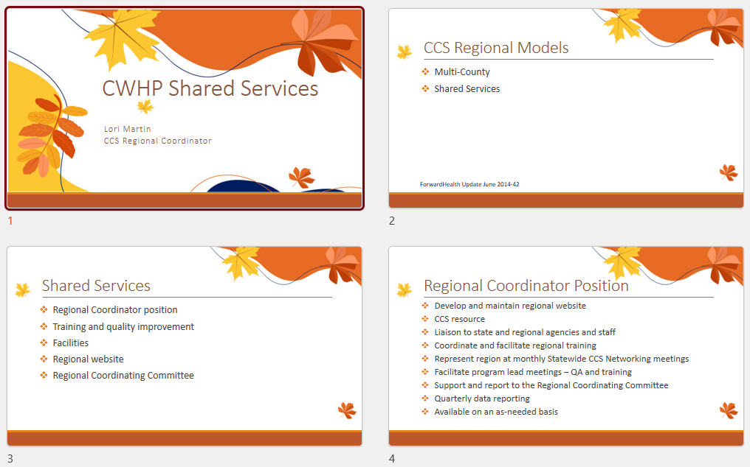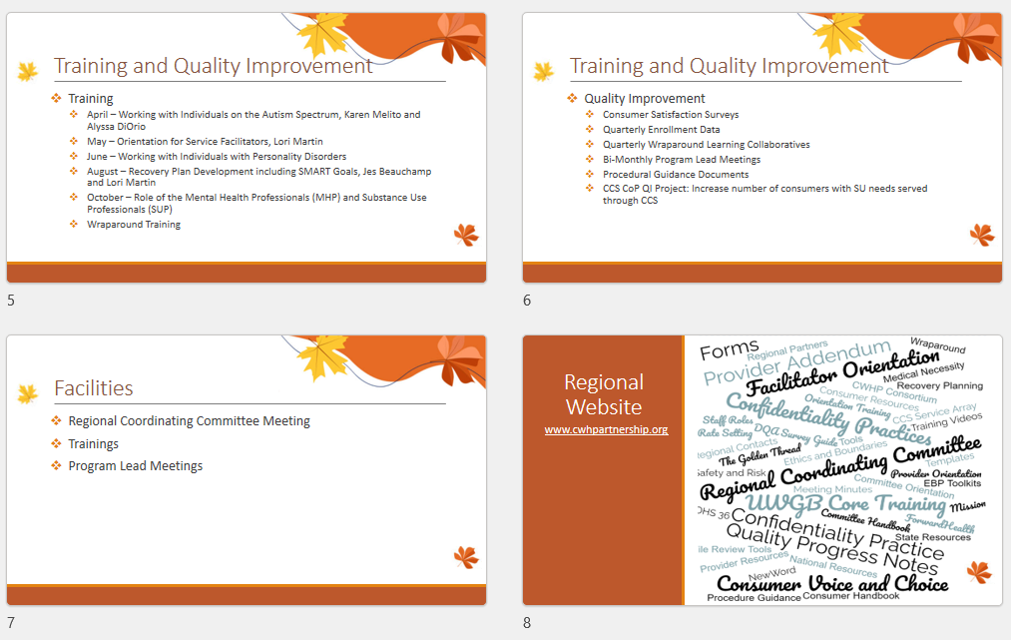

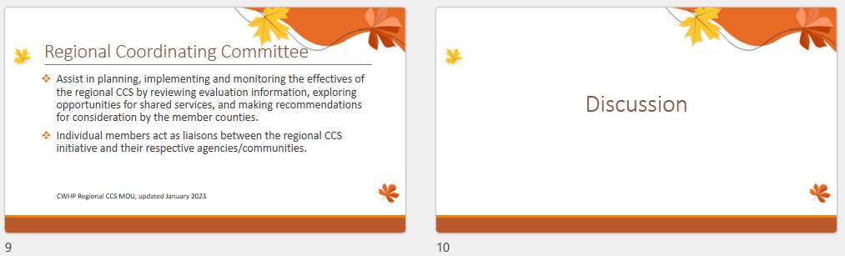

APPENDIX B
