Central Wisconsin Health Partnership
Comprehensive Community Services (CCS)

Procedural Guidance: Determining CCS Provider Orientation Training Needs

Does the provider need 30 hours of training prior to beginning employment with CCS?
Whether or not an individual needs 30 hours prior to employment is based on provider type.
Peer specialists and rehabilitation workers must receive 30 hours of training during the past two years (prior to beginning employment with the CCS) on the following topics: recovery concepts, consumer rights, consumer-centered individual treatment planning, mental illness, co-occurring mental illness and substance abuse, psychotropic medications and side effects, functional assessment, local community resources, adult vulnerability, and consumer confidentiality (DHS 36.10(2)(g) 20 and 21).
Following is a summary of provider types that can provide CCS services per DHS 36.10(2)(g). If you have the qualifications of any of the provider types 1. through 19. or 22., you many not need the 30 hours of training prior to beginning employment.
1. Psychiatrists
2. Physicians
3. Psychiatric residents
4. Psychologists
5. Licensed independent clinical social workers
6. Professional counselors and marriage and family therapists
7. Adult psychiatric and mental health nurse practitioners, family psychiatric and mental health nurse practitioners or clinical specialists in adult psychiatric and mental health nursing shall
8. Advanced practice nurse prescribers
9. Certified social workers
10. Psychology residents
11. Physician assistants
12. Registered nurses
13. Occupational therapists
14. Master's level clinicians in areas directly related to providing mental health services including master's in clinical psychology, psychology, school or educational psychology, rehabilitation psychology, counseling and guidance, counseling psychology or social work.
15. Other professionals shall have at least a bachelor's degree in a relevant area of education or human services.
16. Alcohol and drug abuse counselors
17. Specialists in specific areas of therapeutic assistance, such as recreational and music therapists
18. Certified occupational therapy assistants
19. Licensed practical nurses
20. A peer specialist
21. A rehabilitation worker
22. Clinical students

If an individual has completed the 30 hours prior to employment in another county or region, they should provide documentation of the training to the new county. Depending on certain factors such as if they’re currently providing CCS services, and if not, how long it’s been since they’ve provided services through CCS, they may be able to use these training hours.

Does the provider need 20 or 40 hours of orientation training?

- At any point in your career, have you provided services as a CCS provider for at least 6 months?

  - If the answer is “No” – you will need 40 hours of orientation training

  - If the answer is “Yes”
    - Are you currently providing services in another county or region?
      - If “Yes”, you may be able to provide documentation of the 40 hours you received within 3 months of providing CCS services in the initial county/region. You will be asked to receive additional training related to specific policies and procedures of the CWHP county.
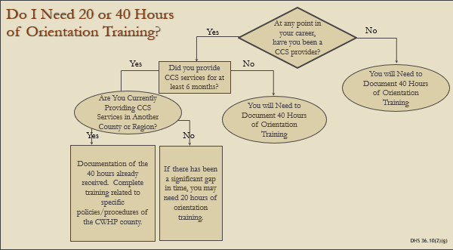
      - If “No”, and there has been a significant gap in time, you may need 20 hours of orientation training.
CSP, TCM, CCS

